Hearing Conservation

Hearing Intro
Millions of Americans are exposed to high noise levels; Short-term overexposure can cause a temporary hearing change (ears feel stuﬀed up) or tinnitus (ringing in ears), which may go away after leaving the noisy area. Repeated overexposure can lead to permanent tinnitus and/or hearing loss. Neither surgery nor a hearing aid can correct hearing loss.

Warning Signs
Is your workplace too noisy? Noise may be a problem in your workplace if:
- You have to raise your voice to communicate on the phone or with nearby coworkers
- You hear ringing or humming in your ears or you experience temporary hearing loss when you leave work

Although hearing loss is commonly contributed to aging, some people lose their hearing earlier in life because of noise overexposure. Noise induced hearing loss is preventable through the following controls (in order of priority):
- Engineering controls reduce sound exposure levels. Examples are:
  - Modifying or replacing equipment
  - Making related physical changes at the noise source to reduce the noise level
⇒ I.E.: Choose low-noise tools and machinery, maintain & lubricate machinery and equipment, place a barrier between the noise source and employee, and/or enclose or isolate the noise source
- Administrative controls are changes in the workplace that reduce or eliminate noise exposure. Examples are:
⇒ Operating noisy machines during shifts when fewer people are exposed
⇒ Limiting the amount of time a person spends at a noise source
⇒ Providing quiet areas where workers can gain relief from hazardous noise sources
⇒ Restricting worker presence to a suitable distance away from noisy equipment
- PPE hearing devices, such as earmuﬀs and plugs, are an acceptable but less desirable option to control noise exposure. PPE is used as necessary to implement safety controls, when the above controls are not feasible.

Applying what we learned: What is the correct order of priority for noise exposure controls?
- PPE, Administrative, then Engineering
- Administrative, Engineering, then PPE
- Engineering, Administrative, then PPE
Answer = C

Loud noise can create physical and psychological stress, reduce productivity, interfere with communication and concentration, and make it diﬃcult to hear. Noise-induced hearing loss limits your ability to hear high frequency sounds, understand speech, and seriously impairs your ability to communicate with loved ones. All of this can cause us to be exposed to unsafe work!

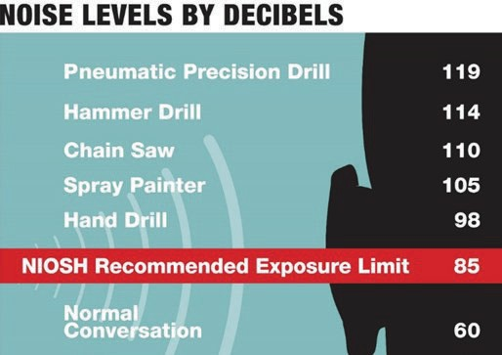

- Use hearing protection in areas greater than 85 decibels
  - Each increase of 3 dB doubles the loudness
  - 2x the distance from the source = 1/2 the noise level
- Clean and inspect hearing protection before each use
- Replace worn or broken hearing protection immediately

Hearing loss is a normal part of growing older. Not all hearing loss is from exposure to loud noise. You may lose about ½ of your hearing by the time you reach 65 years of age. Protect your hearing, once you lose it, you can never get it back! Follow these tips at work and at home to save your hearing before it’s too late.

